

Aerostructures Innovation Hub

(AIR Hub)
  - AIR Pass initial expression of interest form

10 July 2022

AIR Hub

AIR Pass initial expression of interest form

Your initial expression of interest will be briefly evaluated by our team. If you progress, we will provide an extended commercial and project questionnaire. Please refer to the AIR Pass webpage for round closing deadlines.

Please submit your completed PDF version of this initial expression of interest form to airpass@swinburne.edu.au

Your company details
Company name:
Website:
ABN:
Company address:
Describe your principal business location (office, workshop, co-working, etc.):
Full-time employees:
Part-time employees:

Main contact
Title:
Full name:
Position:
Contact telephone:
Email address:

A short summary of your proposition – MAXIMUM TWO A4 PAGES NOT INCLUDING PICTURES

Identified problem & ideal customer:
Prompt:
What is the problem or opportunity that you have identified? Why is it a problem? What impact is this problem having on the customer?

Proposed solution:
Prompt:
What is the solution that you have identified? What will be the benefit to the customer? Are you the first to try this approach? Does the customer believe you can solve the problem? What evidence do your customers need to see to consider it a no-brainer that you have solved the problem?

Customer profiles:
Prompt:
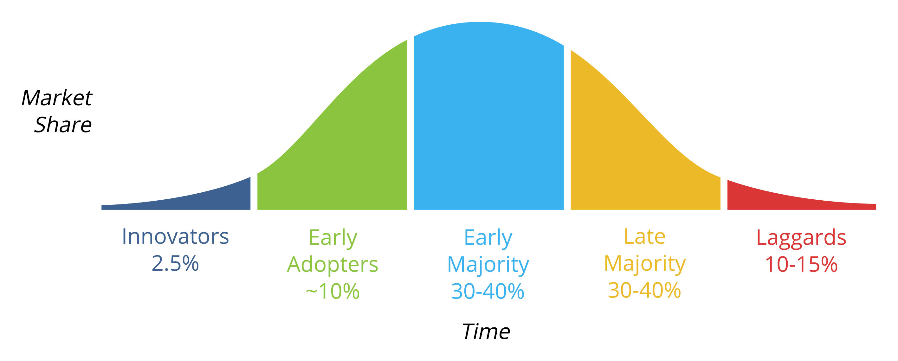
Who is this problem having an impact on? Who will be your first or next customer? Where are they physically located? Please indicate the types of customers in the market using the market adoption curve below as a reference for how you expect customers to adopt your solution.

Vision & Mission:
Prompt:
Is there a bigger vision behind what the company is trying to achieve? What are the missions to achieve that vision? Why are you and your team working on this problem? Where do you want to see the company in five to ten years? What market share do you think you can own?

Proposed project:
Prompt:
This program intents to provide you the opportunity to put a prototype product down in-front of your first or next customer. We have time bounded the initial collaborated prototyping effort to a maximum of six months. We will provide up to A$150,000 in prototyping and research expenses and A$50,000 in start-up expenses.

In every project, it is mandatory to have a customer interaction point. This could be a demonstration, trial or pilot with you first or next customer. We recommend the customer interaction point is done at the 80 per cent project completion, so that you still have some time and resources to make modifications if needed. Our facilities and resources will be 100 per cent behind helping you to succeed. So, what is your proposed project and how can we make it happen?

